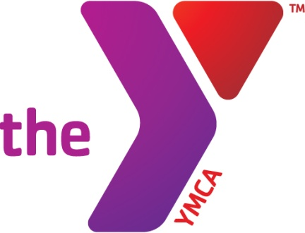

PROGRAM

INFORMATION

Parent Handbook Addendum

Bear-Glasgow YMCA – Before & After School Enrichment

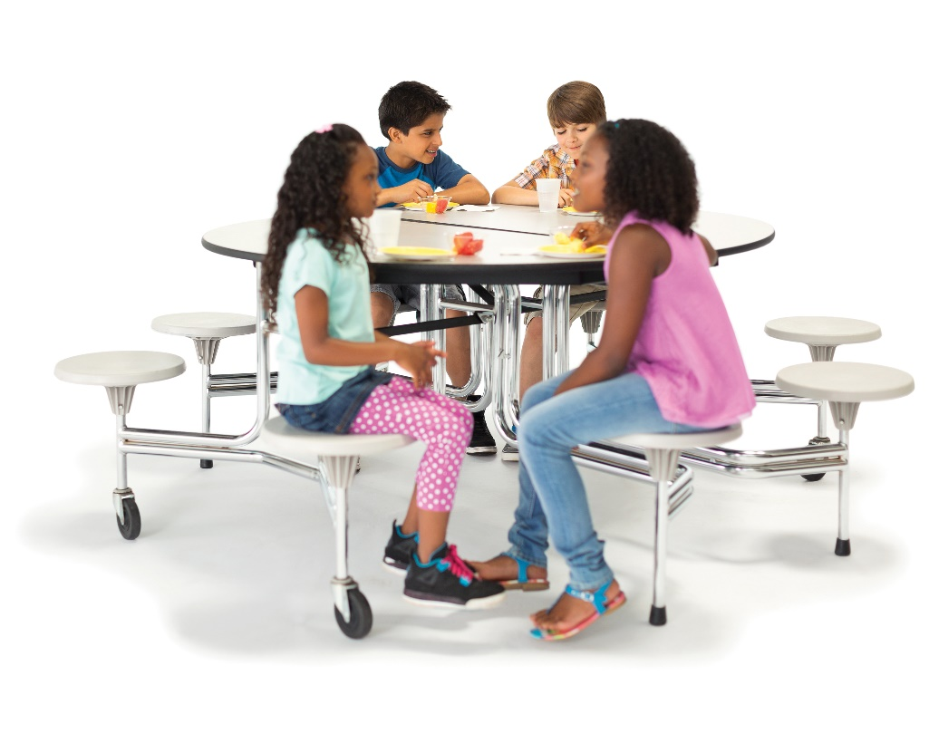

**Bear-Glasgow YMCA**

This program serves children from Kindergarten through Fifth Grade. Our Before & After School Enrichment programs are licensed by the State of Delaware’s Office of Child Care Licensing

**General Information**

**Hours of Operation**

We are open Monday through Friday, 7:00 AM until the start of school and from the end of school until 6pm. We do not offer care at our BASE Sites on Teacher Workdays; however, we often offer Schools’ Out programming at the Bear-Glasgow Branch on these days. Please be sure to read our Procare BASE weekly newsletters to have the opportunity to register for Schools’ Out Programming. Center staff members arrive before 7:00 AM to prepare the center and remain until 6pm to clean up. We kindly ask that parents respect the center hours and allow our staff to complete their daily tasks.

**Our Schools, Contact Info, and POC Site Numbers**

While we encourage parents to use our ProCare application for quick questions for staff, the contact information for each site/classroom is listed below:

|  |  |  |
| --- | --- | --- |
| School | Contact Number | POC Site Number |
| Bear-Glasgow Branch Schools’ Out | 302-836-9622 | 1710409500 |
| Colwyck Early Education Program (CEEP) | 302-932-7211 | 1710371800 |
| Keene Elementary School | 302-932-7671 | 1710236900 |
| Leasure Elementary School | 302-932-3901 | 1710129100 |
| Marshall Elementary School | 302-932-7677 | 1710129300 |
| McVey Elementary School | 302-784-8413 | 1710129200 |
| Pleasantville Elementary School | 302-784-8409 | 1710367100 |
| Wilbur Elementary School | 302-932-7693 | 1710388000 |
| Wilmington Manor Elementary School | 302-784-8393 | 1710387300 |

**YMCA of the USA School Age Curriculum Framework**

Second only to human relationships, a well-planned curriculum will help define a child's experience in a YMCA program. The curriculum affects all aspects of a program: its overall quality, parent perceptions, and the outcomes and benefits of the program on individual children. The YMCA of the USA and Y’s across the country are adopting the YMCA School-Age Care Curriculum framework. The framework discusses the developmental stages of children and youth, describes YMCA beliefs and other frames of reference used in selecting and developing activities, connects the curriculum to the YMCA mission and goals, suggests core content areas, lists sample activities, details additional sources of activities for school-age children and youth, discusses how to use the framework, and suggests how to develop, set up, introduce, and evaluate activities. The eight YMCA core content areas are: arts and humanities, character development, health and fitness, homework support, literacy, science and technology, service learning, and social skills and conflict resolution.

**Developmental Screening & Assessment**

We utilize developmental screenings and assessments in the Before & After School Enrichment program to understand each child’s developmental strengths, individual interests and need for continued growth and support. These tools provide us with information for selecting and providing curriculum activities. These assessments are conducted at least annually and consist of three components:

Program Staff Observation which documents the child’s:

* Social/emotional and character development which addresses issues like the child’s ability to engage with other children, empathize with others, manage conflict, communicate
* Approach to learning which addresses skills like the child’s ability to manage and complete tasks, interest in learning new things, independence in learning, problem solving,
* Personal health and wellness which addresses factors such as the child’s understanding of choices and habits that contribute to health and wellness
* Child’s support system which addresses what is observable about the child’s access to people, systems and materials that support his/her wellbeing and learning

“Getting to Know You” Form (Family/Parent Questionnaire) gives families an opportunity to be engaged in the process and offer the program information about the child from the perspective of family members who are most familiar with the child.

**Your Child’s Day**

# What to Bring

Children will need to wear clothing and footwear and socks suitable for sports, being active, doing crafts, and getting messy. Participants should also bring any materials needed to transport to or from school.

**What to Leave at Home**

Children are not to bring dolls or toys (unless requested for a specific program), pets, game boys or electronic games, iPods/mp3 players, (children may bring music for specific programs), sports equipment, expensive equipment or jewelry, cell phones, skateboards, roller blades, and scooters, weapons, drugs, alcohol, cigarettes/vaping devices, and money. Toy guns, knives, swords, and other toys that promote aggressive behavior do not promote the type of learning and cooperative play according to the principles of our program, please leave these at home.

**Meals & Snacks**

As a participant in the Child & Adult Care Feeding Program (CACFP), our program serves supper between 4:00 and 4:30 pm. Each supper includes a serving of meat, grain, milk and two fruits/vegetables.

**Typical Daily Schedule**

Schedules for each group are established by the staff based upon the developmental needs and abilities of the group. These schedules are updated regularly and are posted in the classroom/group space.

**Activity Centers**

# Our activity areas are divided into centers to help guide the activities and learning opportunities each child experiences. Each day, children have opportunities to self-select centers to play and learn in. Our centers include:

# Dramatic Play

# Manipulatives

# Blocks

# Art

# Science

# Library/Writing

# Music

**Drop OFF/Pick Up**

**Drop Off and Pick Up Varies by BASE Site**

**CEEP, Keene, Leasure, Marshall**

**Please Park your car in the school parking lot and proceed to the front door of the school. Call the Site Phone number and a staff member will assist you.**

**Wilbur**

**Please drive around to the back of the school and proceed to the door to the right of the dumpsters. Call the Site Phone number and a staff member will assist you.**

**Wilmington Manor**

**Please Park your car in the parking lot and proceed to the door to the left of the main entrance. (This is the cafeteria entrance) Please knock on the door and a staff member will assist you.**

**McVey & Pleasantville**

**Please drive around to the back of the school and park your car. Proceed to the cafeteria door and knock on the door. A staff member will assist you.**

## Drop Off Times

Please remember to accompany your child into our center and sign them into the program. ***Parents are requested to send a ProCare message to the YMCA by 7:30 am whenever a child will not be attending on a scheduled day. We appreciate your assistance with this as this ensures a smooth afternoon pick-up at the schools if we know in advance that your child is not at school or has had an early dismissal.***

## Pick-Up Times

Our scheduled pick-up time is 4:00 – 6:00 PM. You must sign your child out when picking up each day.

**Parent Communication**

**Information Board**

The Before & After School Enrichment information board is displayed at your child’s BASE site.

**Weekly Update**

Weekly newsletters are sent through our ProCare application to keep parents current on information regarding our program. ￼